Resource 3d
Resource 3d
Resource 3d
Resource 3d

“I thought we were going to the pub”

“She said she’ll be here in
a minute”

“We didn’t want to
disturb you”

“What do you think he meant by that?”

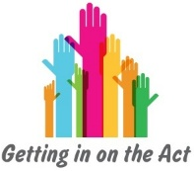
Angry

Disappointed

Relieved

Scared

Excited

Doubtful

Comforting

Frustrated

Amused

Angry

Scared

Confused
Resource 3d
Resource 3d
Resource 3d
Resource 3d

“So we’ve got to go to the shop now”

“Is he going to be at
the party?”

“I wouldn’t worry about it”

“I’m going to go”

Angry

Questioning

Happy

Worried

Excited

Annoyed

Comforting

Dismissive

Happy

Fed up

Excited

Upset

