

Consultation document

Social Care Wales Strategic Plan 2017 - 2022

Consultation closes on 11 August 2017

**Contact details**

**Social Care Wales**

South Gate House

Wood Street

Cardiff

CF10 1EW

Tel: 0300 3033 444

Minicom: 029 2078 0680

Email: info@socialcare.wales

**socialcare.wales**

Twitter: @SocialCareWales

© 2017 Social Care Wales

All rights reserved. No part of this publication may be reproduced, stored in a retrieval system or transmitted in any form or by any means without the prior written permission of Social Care Wales. Enquiries for reproduction outside the scope expressly permitted by law should be sent to the Chief Executive of Social Care Wales at the address given above.

**Overview**

The purpose of this consultation is to seek your views on our Strategic Plan.

**How to respond**

You may respond by completing the on-line survey or by sending your written response/email to the address provided. <https://www.surveymonkey.co.uk/r/6JMVXGP>

Rhian Jones

Social Care Wales

South Gate House

Wood Street

Cardiff

CF10 1EW

[Rhian.Jones@SocialCare.Wales](mailto:Rhian.Jones@SocialCare.Wales)

**Further information and related documents**

Large print, Braille and alternative language versions of this document are available on request using the above contact details.

**Data protection: How the views and information you give us will be used**

Any response you send us will be seen in full by Social Care Wales staff dealing with the issues this consultation is about. It may also be seen by other members of staff to help plan future consultations.

We will publish a summary of the responses to this document. We may also publish responses in full. Normally, the name and address of the person or organisation who sent the response are published with the response. This helps to show the consultation was carried out properly. If you don’t want your name or address published, please tell us in writing when you send your response. We will then blank them out.

Names or addresses we blank out might still get published later, though we do not think this would happen very often. The Freedom of Information Act 2000 and the Environmental Information Regulations 2004 allow the public to ask to see information held by many public bodies, including Social Care Wales. This includes information that has not been published. However, the law also allows us to withhold information in some circumstances. If anyone asks to see information we have withheld, we will have to decide whether to release it or not. If someone has asked for their name and address not to be published, that is an important fact we would take into account. However, there might sometimes be important reasons why we would have to reveal someone’s name and address, even though they have asked for them not to be published. We would get in touch with the person and ask their views before we decide to reveal the information.

Foreword

Our strategic plan consultation sets out our vision for the next five years,



what we aim to achieve, what our focus will be and how we will work

with you to deliver our ambition.

The vision for social care in Wales is clear: the focus is on the

well-being of the people of Wales with a strong voice and control

over the care and support they receive. Social care has a key role to

play to improve well-being, to act on what matters to individuals by

working with partners across public services and communities.

This requires improvement in services, cultures and practice,



which are person centred and recognise the strengths and expertise

of people, carers and communities we support. That is the essence

of the Social Services and Well-being (Wales) Act 2014 which

will guide public services for the years ahead, alongside the

Regulation and Inspection of Social Care (Wales) Act 2016 to

modernise the regulation and improvement arrangements, focusing

on regulation for success.

Social Care Wales was established in April 2017 bringing together

social care workforce regulation, workforce development and service

improvement in one organisation. We will have an influential role in shaping research priorities, building strong links with key stakeholders to improve care and support. We will be a key leadership partner in the new social care landscape in Wales

We have new responsibilities and expectations to provide a strong national leadership voice for social care and early years. To remain credible and relevant, we will need to be able to reflect individuals, sector and ministerial concerns and priorities, in order to shape our work and inform and support the work of others. We will work in partnership, build on our experience and expertise, learn from best practice and take advantage of technological advances to communicate and engage.

Our purpose, vision and aims reflect our legal powers and responsibilities[1] and the views of the sector and stakeholders involved in our creation.

As a Welsh Government Sponsored Body we are committed to supporting the delivery of *Taking Wales Forward,* the Programme for Government 2016-2021, the principles of the Wellbeing of Future Generations (Wales) Act 2015 and our responsibilities as a Welsh public service organisation.

By supporting the care workforce we will help children, adults and older people who receive care and support improve their health and well-being and do what matters to them.  Through regulation and training we want to improve the quality and status of employment in social care, to ensure better jobs, closer to home for people across Wales.  In driving service improvement and new models of service delivery we want to focus on principles that underpin successful implementation across Wales.

We are working through what this means for us, as Social Care Wales, in delivering our aims. We can only achieve our aims by working together with you in partnership. We will be answerable to you for our work through the National Assembly and Welsh Ministers. Therefore, we would welcome your feedback so that we are confident in your support in delivering our vision.

Our strategic plan will not provide the detail of our activities, these will be set out in annual business plans which you will find on our website.

Arwel Ellis Owen Sue Evans

Chair Chief Executive



Who we are

Social Care Wales was established as one of the first acts of primary legislation passed by the National Assembly. This reflects the national importance of social care in Wales.

We have a responsibility, in legislation, to “protect, promote and maintain the safety and well-being of the public in Wales”.

What we do

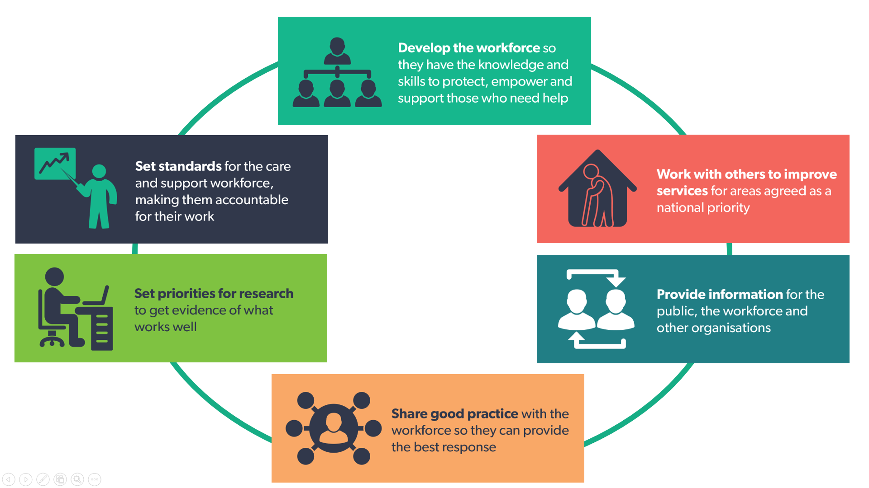

We will work across organisational and service boundaries, with people who access care and support with carers and with Welsh Government on the basis of a shared ambition, working together towards solutions.

We commit to our leadership role brokering new knowledge, innovation and relationships across the whole system. Building, energising and strengthening a collaborative environment that will drive positive change in Wales.

As a new organisation, we will drive forward the good work that has been done to improve social care in Wales and grasp opportunities to further develop our improvement function. We will build on the relationships we have with the sector to make sure that our identified priorities have a tangible impact.

Working with our partners three national priorities for improvement in social care have been agreed:

* Dementia
* Children who are looked after
* Care and support at home.

In our first five years, we will be focusing on these improvement areas. Important work is already taking place to address these issues, through national strategies and we will make sure our priorities are aligned with these.

It is important to note that we will also be continuing to develop and deliver our work which go beyond these three national priorities.

There will be opportunities for you to inform the detail of our work through a number of consultations. These consultations will be looking at specific areas of our work such as:

* Regulation on the care and support workforce
* Research strategy
* Care and support implementation action plan
* Strategic Equalities plan

Further information on these consultations can be found through our website: [www.socialcare.wales/consultations](http://www.socialcare.wales/consultations)



Our plan

Our five year plan defines our vision, purpose, aims and outcomes. It also describes our approach to how we will deliver. It will not set out the detail of what we will be doing; this will be included within our annual business plans.

We will reflect each year to ensure we are continuing to do the right things in the right way, making change where necessary, we welcome your ongoing feedback and partnership in supporting the progression of work. Our strategic plan has been developed by the Board and will be used by them to scrutinise delivery, holding officers to account. We will share our progress with you, via our website and engagement activities.

Our vision

**We want every person who needs support to live the life that matters to them**

Our purpose

**Building confidence in the workforce and driving improvement in social care**

Our aims

Our strategy is being developed in the context of Social Care Wales being part of the wider Welsh public service. Our work aims to support the priorities for the well-being of future generations, for the whole sector, the public and Welsh Government.

Our three strategic aims will define what we do and our actions to deliver. The aims will result in:

* improved well-being outcomes for individuals using care and support, their families and carers
* a high quality, sufficient and skilled workforce
* people having confidence in the social care workforce and the effectiveness of Social Care Wales

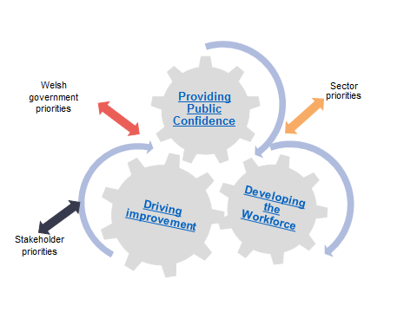

Our strategic plan is being developed using an outcomes-based approach. This will help us clearly show the beneﬁts of regulation, standards and workforce development in improving the social care and early years workforce. It will also allow us to highlight how our service improvement activities contribute to safeguarding and improving the well-being of individuals, families and communities.

We are developing a range of indicators which will measure the impact of our work. These will be included in our strategic plan when published in September.

In the next pages we have set out our outcomes for each of the three strategic aims and where we will focus our energy and commitment to work with you over the next five years to deliver our vision.

**We want Wales to have a sufficient, high quality and skilled social care and early years workforce**

**Our action to deliver this**

**We will support sustainability of the workforce through:**

* **delivering a recruitment, retention and careers framework**
* **delivering resources to support employers and the workforce**

**We will improve the quality and management of social work and social care training through:**

* **influencing, investing and delivering national training and development programmes**

**We will support the workforce to improve practice in line with social care legislation and evidence through:**

* **identifying and sharing practice and supporting innovation**
* **delivering workforce plans to meet future needs**

**We want improved outcomes for individuals using care and support and their families and carers**

**Our action to deliver:**

**We will drive national service improvement priorities through working with partners in:**

* **delivering the care and support strategic plan**
* **developing and implementing improvement programmes for dementia care and children who are looked after**

**We will establish effective approaches to service improvement and work with you to decide future priorities**

**We will deliver a national research and development strategy to support policy and practice**

**We will use data and evidence to improve services by delivering a national social care data set**

**We want people to have confidence in the social care sector and in the effectiveness of Social Care Wales**

**Our action to deliver**

**We will ensure the social care workforce is fit to practise through our regulatory role by:**

* **maintaining professional standards**
* **assuring high quality accredited training**

**We will be an effective and transparent organisation through:**

* **working with you**
* **being accountable for our decisions**



How we will work

We recogniseand value diversity. We will make sure our work embeds and shows our public duty as set out by the Equality Act 2010. To make sure we do this effectively, we will be consulting with you on our strategic equalities plan.

If we are to achieve our vision, the availability of clear, good-quality information about professional standards, research and service models must be easily accessible to the workforce, stakeholders and the public. In a rapidly changing environment we will use our leadership role to help make this happen. Digital channels will provide opportunities to share information and training programmes more widely, efficiently and effectively. We will be expanding and improving the ways in which we communicate and engage with our stakeholders. We will embrace a ‘digital first’ approach to continually evolve and improve our reach.

We will champion the importance of language need for people who use care and support, and their families and carers. We have a leadership role in supporting delivery of the Welsh Government’s ‘More than just words – strategic framework for Welsh language services in health, social services and social care’. As a public service employer we will make sure we are a bilingual organisation that complies with Welsh language standards and actively offers welsh language services to our customers. We will provide an environment that promotes Welsh language use, and nurtures staff to learn Welsh and improve their bilingual skills, so that the language is used every day.

It is important that, as a public leadership organisation, we demonstrate our values in the way we work with you to deliver our vision.

Our values

**Respect everyone:** we see people as individuals and treat everyone with dignity and respect

**Professional approach:** we act responsibly and in the right way, holding each other to account

**Always learning:** we believe in improving ourselves and supporting others to be the best that they can be

**Involve people:** we encourage and enable everyone to work together

Over the past 18 months we have been listening to your feedback about your expectations for Social Care Wales. This is what we have heard from you about how we should be working as a leadership organisation:

We welcome your feedback

To help consolidate our five-year vision we would be grateful if you could take the time to answer these questions:

|  |
| --- |
| 1. Is our vision (our goal) and purpose (the why we are here) clear? (page 5) |
| Yes No |
| Comments |

|  |
| --- |
| 2. Do our aims support our vision and purpose? (page 6) |
| Yes No |
| Comments |

|  |
| --- |
| 3. Will our aims have any positive or negative impacts on groups with protected characteristics[2]? (pages 6-9) If so, which and why or why not? |
|  |

|  |
| --- |
| 4. Do you agree with the approach we are using to deliver our vision? (pages 10-11) |
| Yes No |
| Comments |

|  |
| --- |
| 5. Are there any other important actions that you would like Social Care Wales to lead in future? (pages 7-9) |
| Yes No |
| Comments |

The closing date for the consultation is 11 August 2017. Following the closing date, your comments will be considered. A report about the responses received will be published on our website. Our strategic plan will be published and launched by the Minister for Social Services and Public Health on 28 September 2017.

Other consultations connected to our work will have different closing dates. You can stay up-to-date with the outcome of these consultations through our website: [www.socialcare.wales/consultations](http://www.socialcare.wales/consultations)

Thank you again for your time in giving your views and feedback on our strategy.

1. The legislative white paper *Sustainable Social Services for Wales: A Framework for Action* was published in 2011.   Subsequently, the Regulation and Inspection of Social Care (Wales) Act, 2016 created Social Care Wales. 
2. Protected characteristics are: age, disability, gender reassignment, marriage and civil partnership, pregnancy and maternity, race, religion and belief, sex, and sexual orientation.