

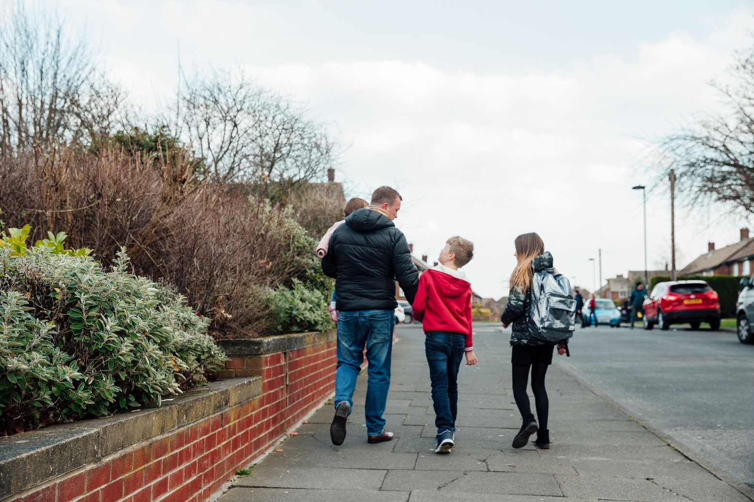

National Safeguarding Training Standards

Have your say on the proposed draft training standards

Closing date: 17 June 2022



# Contact details

**Social Care Wales**

South Gate House

Wood Street

Cardiff

CF10 1EW

Tel: 0300 3033 444

Minicom: 029 2078 0680

Email: info@socialcare.wales

Twitter: @SocialCareWales

© 2022 Social Care Wales

All rights reserved. No part of this publication may be reproduced, stored in a retrieval system or transmitted in any form or by any means without the prior written permission of Social Care Wales. Enquiries for reproduction outside the scope expressly permitted by law should be sent to the Chief Executive of Social Care Wales at the address given above.

**Other formats:** This document is available in other formats if required and you can request these by using the contact details above. This document is also available in Welsh.

# 

**About the National Safeguarding Training Standards**

Social Care Wales has been leading on the development of the National Safeguarding Training Standards. The standards have been co-produced by a multi-agency national development group as well as other groups focused on specific aspects of the work.

The standards were developed because there:

* were no multi-agency, national standards for safeguarding training in place
* was a lack of consistency in the design, content and provision of safeguarding training across organisations in Wales
* was confusion around the appropriate levels of safeguarding training for the workforce.

The standards will help organisations make sure:

* they incorporate the standards for practitioners into their safeguarding policies and procedures
* practitioners understand their responsibilities relevant to the group they’re in and how to follow the relevant policies and procedures
* all practitioners have access to and comply with the Wales Safeguarding Procedures.

**Who are the training standards for?**

The training standards are relevant to everyone working in:

* local authorities
* social care
* early years and childcare
* health
* police
* education
* probation
* inspectorates
* third and independent sector organisations
* commissioned providers
* agencies or organisations that work with all the above services.

We’ve split the standards into six groups (A to F) that reflect the roles and responsibilities of people who may be involved in safeguarding practice.

The multi-agency National Safeguarding Standards Development Group chose the term ‘groups’ and agreed that the groups will be consistent with the levels noted in the roles and competencies for healthcare staff (children and adults). So Group A, for example, is equivalent to Level 1.

## How to respond

If you’d like to have your say on our proposed national safeguarding training standards, you can do so by:

* completing the online survey at [www.surveymonkey.co.uk/r/D6TKV5G](https://www.surveymonkey.co.uk/r/D6TKV5G)
* completing this document and emailing it to [consultations@socialcare.wales](mailto:consultations@socialcare.wales)
* requesting a discussion with a member of the project group via the email above .

The closing date for the consultation is 11.59pm, 17 June 2022.

Thank you for taking the time to tell us what you think.

# About you/your organisation

Are you responding to this consultation:

1. as an individual

If you’re responding as an individual, are you:

a person who uses care and support

an early years and childcare worker

a healthcare worker/manager

a social care worker/manager

a social worker

a health professional – clinical

someone who works in the prison service

someone who works in the probation service

someone who works in the third sector

an educational professional

a member of the public

other – please describe below:

1. on behalf of an organisation or network

If you’re responding as an organisation, is the organisation:

regional safeguarding board

central or devolved government

a local authority

a social care employer

an early years employer

a learning provider

a health organisation

a police service

a probation service

an education provider

a third sector organisation

network – please name below:

other – please describe below:

Organisation name or network:

# Consultation questions

We welcome your views about the National Safeguarding Training Standards and would be grateful if you could take the time to answer the following questions:

|  |
| --- |
| 1. **Do you agree that these training standards align with the current safeguarding arrangements? (Social Services and Well-being (Wales) Act 2014 and the Wales Safeguarding Procedures)** |
| Yes  No |
| Comments |

|  |
| --- |
| 1. **Do the six groups (A to F) set out in the standards represent the main roles in the safeguarding process? If anything’s missing or unnecessary, let us know in the box below.** |
| Yes  No |
| Comments |

**Please note, you are not expected to be able to answer on all groups (Q3 to 8) but please do try and answer those that are relevant to you and/or your workforce.**

|  |
| --- |
| 1. **Is Group A clear and does it give enough information? If anything is missing or unnecessary, let us know in the box below.** |
| Yes  No |
| Comments |

|  |
| --- |
| 1. **Is Group B clear and does it give enough information? If anything is missing or unnecessary, let us know in the box below.** |
| Yes  No |
| Comments |

|  |
| --- |
| 1. **Is Group C clear and does it give enough information? If anything is missing or unnecessary, let us know in the box below.** |
| Yes  No |
| Comments |

|  |
| --- |
| 1. **Is Group D clear and does it give enough information? If anything is missing or unnecessary, let us know in the box below.** |
| Yes  No |
| Comments |

|  |
| --- |
| 1. **Is Group E clear and does it give enough information? If anything is missing or unnecessary, let us know in the box below.** |
| Yes  No |
| Comments |

|  |
| --- |
| 1. **Is Group F clear and does it give enough information? If anything is missing or unnecessary, let us know in the box below.** |
| Yes  No |
| Comments |

|  |
| --- |
| 1. **Do you recognise your own workforce or role in the group descriptions? If not, how can we make them clearer?** |
| Yes  No |
| Comments |

|  |
| --- |
| 1. **What opportunities do organisations need to think about when embedding the standards?** |
| Comments |

|  |
| --- |
| 1. **What challenges do organisations need to think about when embedding the standards?** |
| Comments |

|  |
| --- |
| 1. **Is there anything else we should include in the standards? If so, what should it be?** |
| Comments |

|  |
| --- |
| 1. **Is child-/person-centred practice addressed sufficiently in the standards? If anything’s missing or unnecessary, let us know in the box below.** |
| Yes  No |
| Comments |

|  |
| --- |
| **14. What effects will our proposals have on the Welsh language, specifically on:**  **i) opportunities for people to use Welsh**  **ii) treating the Welsh language no less favourably than the English language.**  **How could we increase the positive effects or reduce the negative ones?** |
| Comments |

|  |
| --- |
| **15. Do the standards have an impact on those with protected characteristics?**  *The protected characteristics are age, disability, gender reassignment, marriage and civil partnership, pregnancy and maternity, race, religion or belief, sex and sexual orientation.* |
| Yes  No |
| Comments |

**How we will use your views**

Any response you send us will be seen in full by our staff and members of the national development group dealing with the issues this consultation covers. It may also be seen by other members of staff to help us plan future consultations.

We will be publishing a summary of the responses to this document. We may also publish the responses in full. Normally, the name and address of the person or organisation who sent the response are published with the response. This helps show that the consultation was carried out properly. If you do not want your name or address published, let us know in writing when you send your response. We will then blank them out.

Names or addresses we blank out might still get published later, but we do not think this would happen very often. The Freedom of Information Act 2000 and the Environmental Information Regulations 2004 allow the public to ask to see information held by many public bodies, including Social Care Wales. This includes information that has not been published.

But the law also allows us to withhold information in some circumstances. If anyone asks to see information we have withheld, we will have to decide whether to release it. If someone has asked for their name and address not to be published, that is an important fact we would take into account. There may sometimes be important reasons why we would have to reveal someone’s name and address, even though they have asked for them not to be published. We would get in touch with the person and ask their views before we decided to reveal the information.